**Basic Programming Assignment Meeting 6**



**From:**

AL AZHAR RIZQI RIFA’I FIRDAUS

**Class:**

1 I

**Absence:**

01

**Major:**

Information Technology

**Study Program:**

Informatic Engineering

**Assignment 1**

JNX expedition serves domestic and international shipments with the following details:

• For domestic shipments, if the weight of the goods is less than 5 kg then there is no charge, if the goods weigh 5-10 kg then a fee of IDR 165,000 is charged, and if the weight of the goods is more than 10 kg then a fee of IDR 375,000

• For international shipments, if the weight of the goods is less than 2 kg, there is no charge, if the weight of the goods is more than 2 kg, a fee of IDR 500,000 is charged.

Create a flowchart to determine the shipping costs that must be paid by customers!

**Answer**

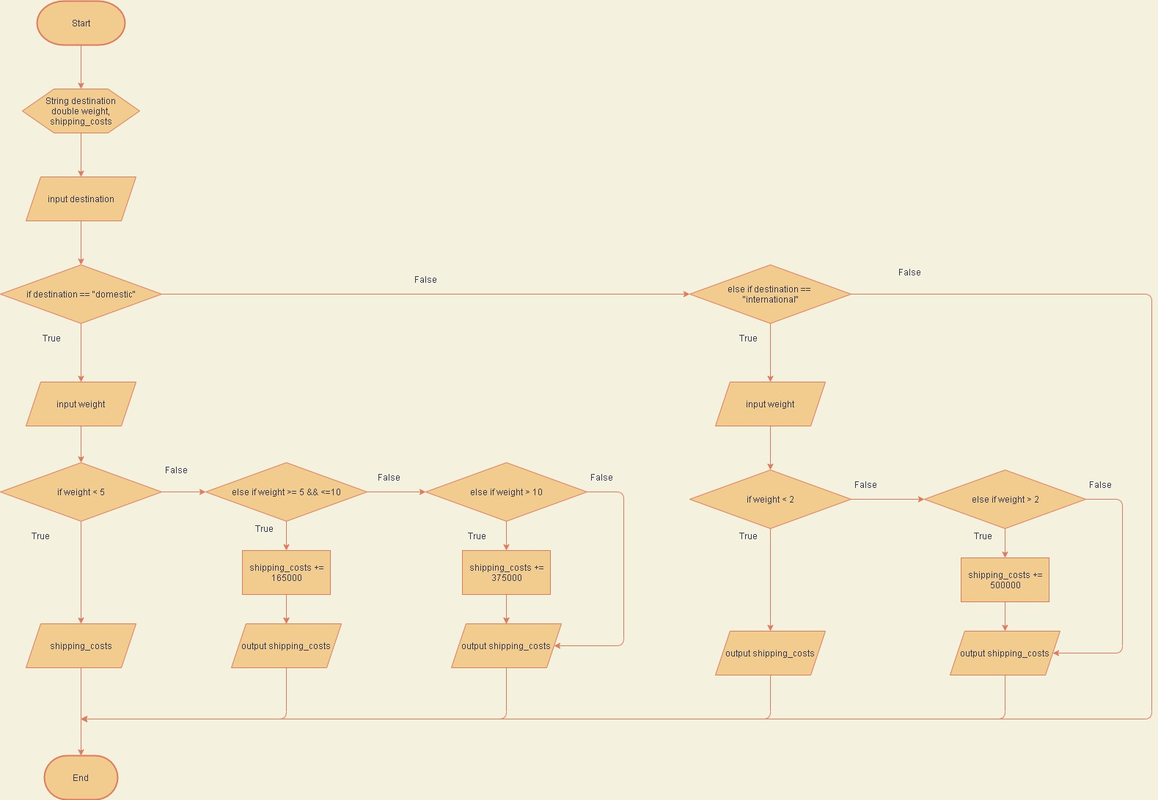

**Assignment 2**

The ATM system has 3 menus, namely Withdrawal, Transfer, and Change PIN

• On the Withdrawal menu, users are asked to select the type of savings “Giro” or “Deposito”, then enter the amount of money to be withdrawn

• On the Transfer menu, users are asked to select the destination bank code consisting of BRI, BNI, Mandiri, Bukopin, and BCA, then enter the destination account, and enter the amount of money to be transferred

• On the Change PIN menu, the user is asked to enter the old password and the new password

Make a flowchart for the ATM system!

**Answer**

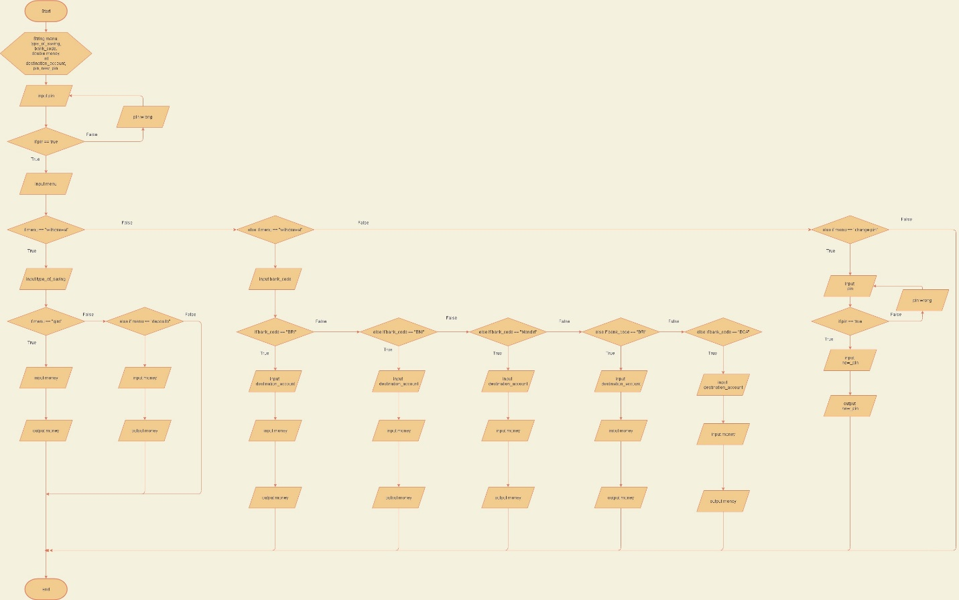

**Assignment 3**

Every Saturday, a clothing store gives a discount to its customers according to the type of clothes and the number of clothes purchased

• A 10% discount is given if the clothes purchased are jackets, then an additional 2% discount will be given if more than 2 clothes are purchased

• A discount of 7% is given if the clothes purchased are shirts, then an additional 2% discount will be given if the clothes purchased are more than 3, whereas if the clothes purchased are less than or equal to 3, an additional 1% discount will be given

• Customers will get a 5% discount for clothes other than jackets and shirts if the clothes purchased are more than 3 products

Make a flowchart to determine the total amount to be paid if the input is the type and quantity of clothes (the price of each garment is determined by the system)!

**Answer**

